CENWP-OD-B
08 September 2008
MEMORANDUM FOR THE RECORD

SUBJECT: Two dead chinook at Bonneville’s Adult Fish Facility (AFF).

On 5 September, CRITFC reported two dead, unclipped adult chinook in the AFF to the Project Fisheries biologist. At 1230 the biologist arrived at the AFF to inspect the fish. Photos are attached below. The fish appeared to be in good condition with no obvious causes of death. CRITFC had sampled and tagged both fish. Information they provided is below.

- Species – Chinook.
- Origin – wild, unclipped
- Length – 83.5 cm and 94 cm
- Weight – Unknown
- Marks and Injuries noted during tagging- The 94 cm fish had a hole in the nose area. It was an older wound that had partially healed over.
- Marks and Injuries found on the carcass– none
- Cause and Time of Death – Unknown
- Future and Preventative Measures – NA
- Other- the 83.5 cm fish had PIT tag #3D9.1C2CCCC4F6. The 94 cm fish had PIT tag #3D9.1C2CCA7F70

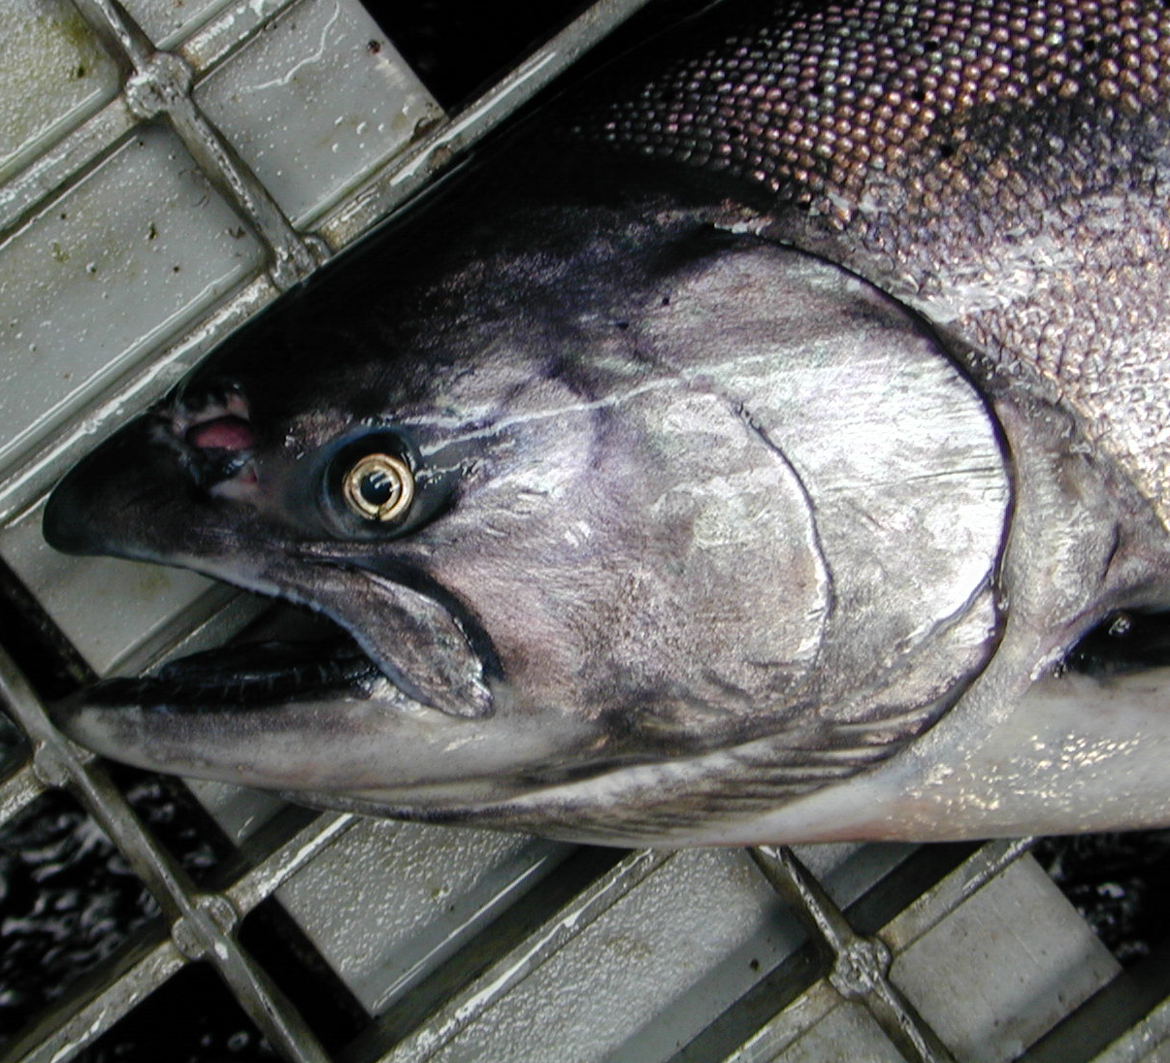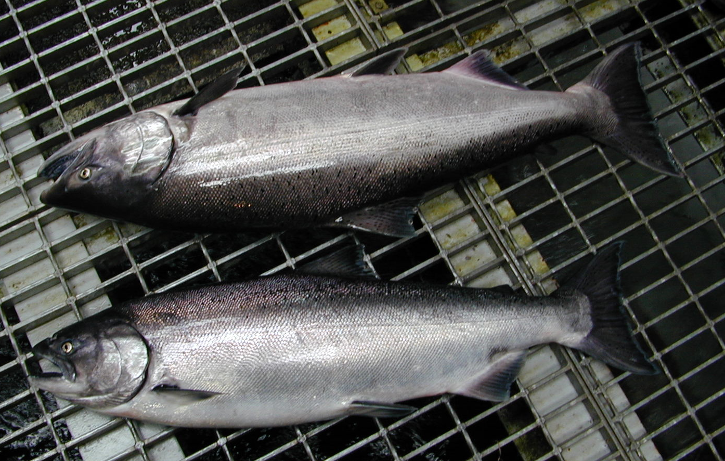
Photo 1. Old wound in the head. Photo 2. Two dead unclipped chinook

Bonneville Fisheries

